Hey Bob,

Any chance we can get 86gb added to each of the data disks on xhepydbw23q first thing tomorrow?    We came up short on space when trying to create the standby database today.  We are planning to switchover to this server at 12:00pm tomorrow.

Thanks

Rich,

All set

500.00 GB      VOLDAT01

500.00 GB      VOLDAT02

500.00 GB      VOLDAT03

500.00 GB      VOLDAT04

500.00 GB      VOLDAT05

500.00 GB      VOLDAT06

500.00 GB      VOLDAT07

500.00 GB      VOLDAT08

Specify appropriate server name in Search Target Name field (top right)

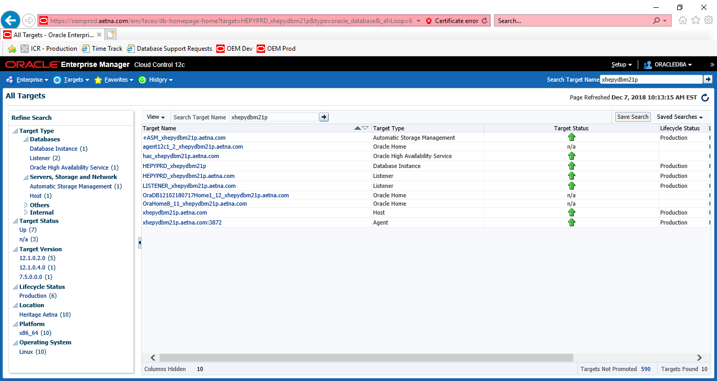

Click on appropriate +ASM instance

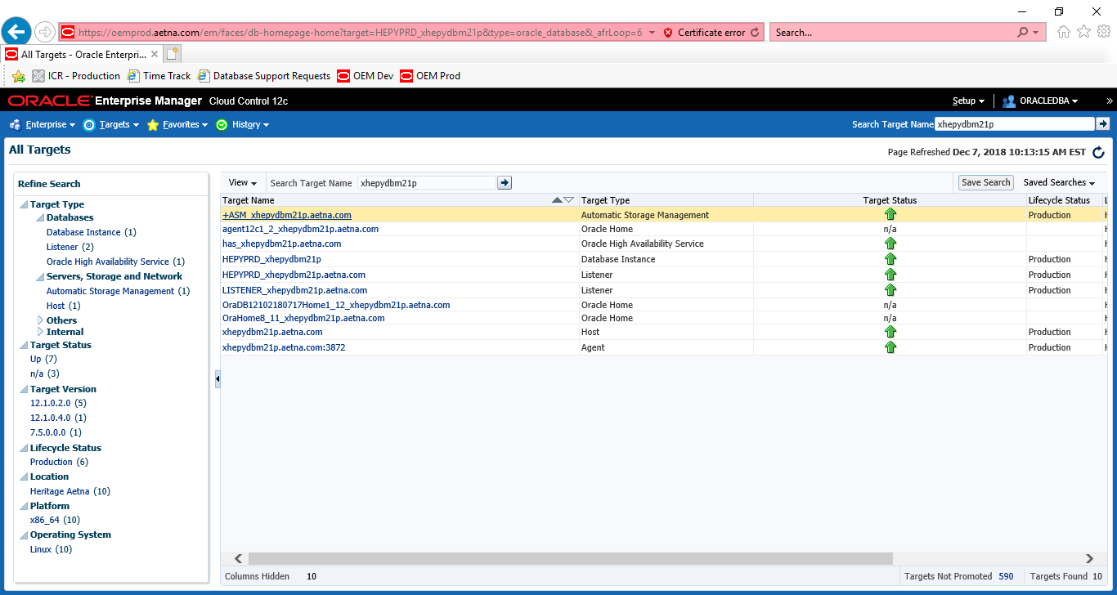

Click on Disk Groups under Automatic Storage Management.

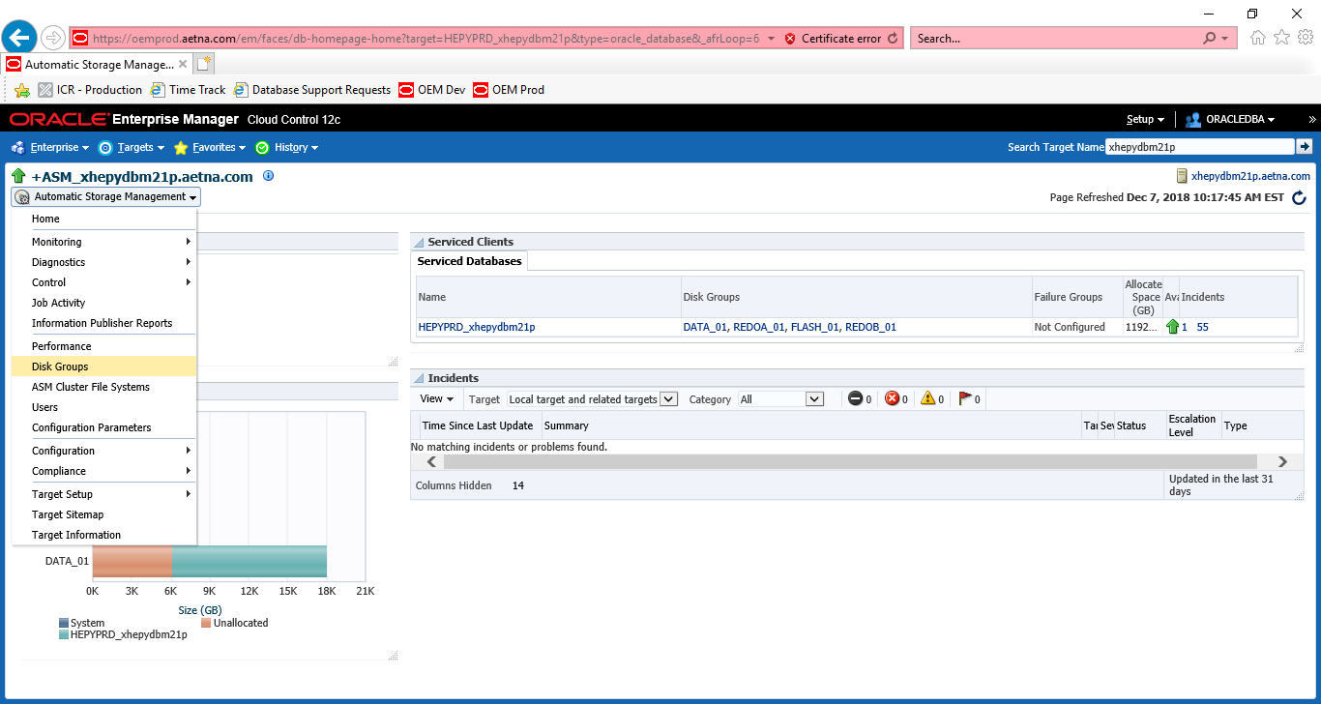

Login with Username: SYS

P: SYSASM

Role: SYSASM

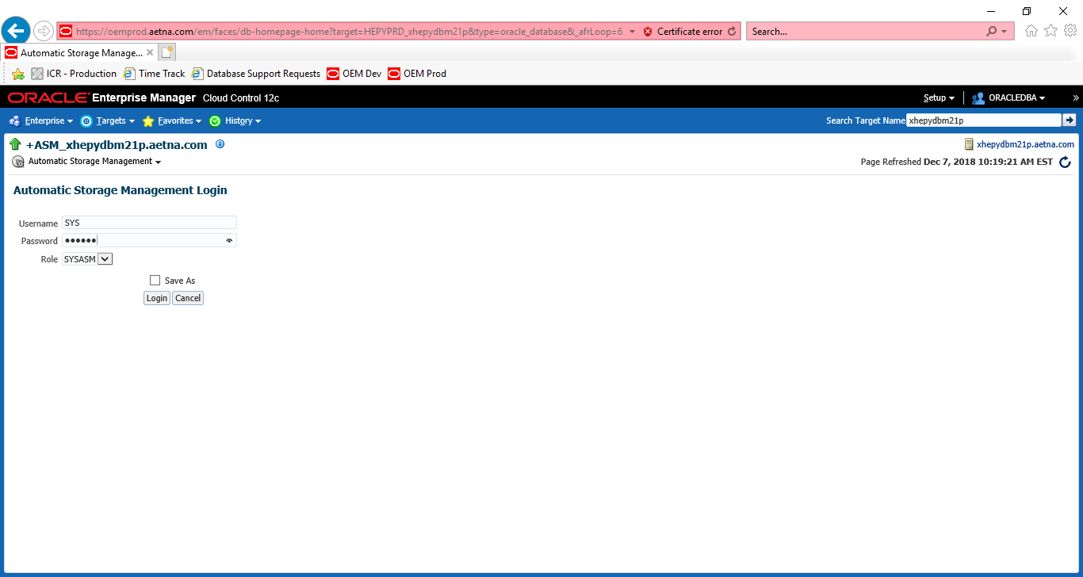

Select Disk group you need to do rebalance

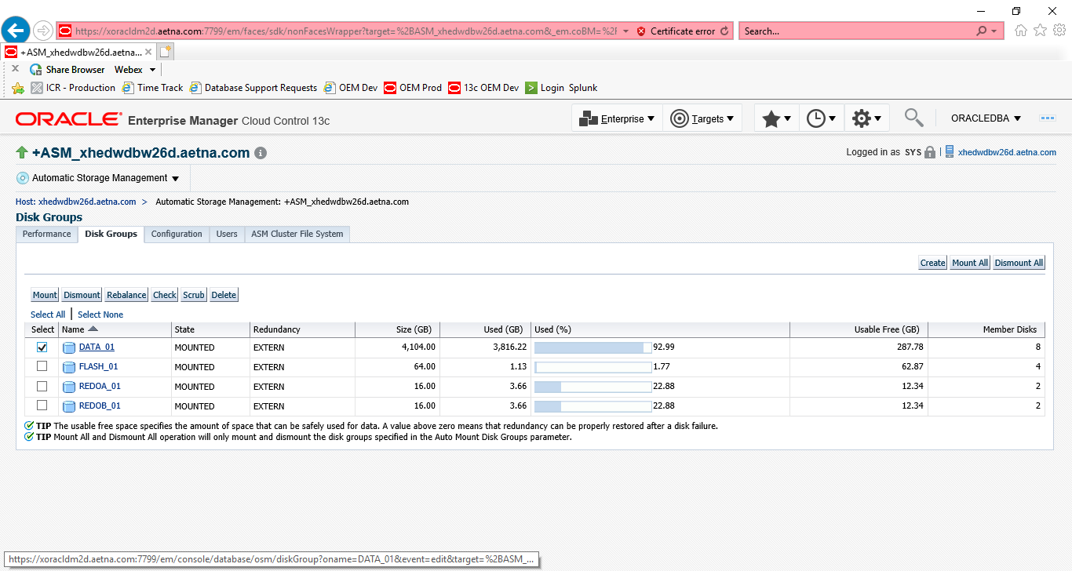

Select ALL and click Resize

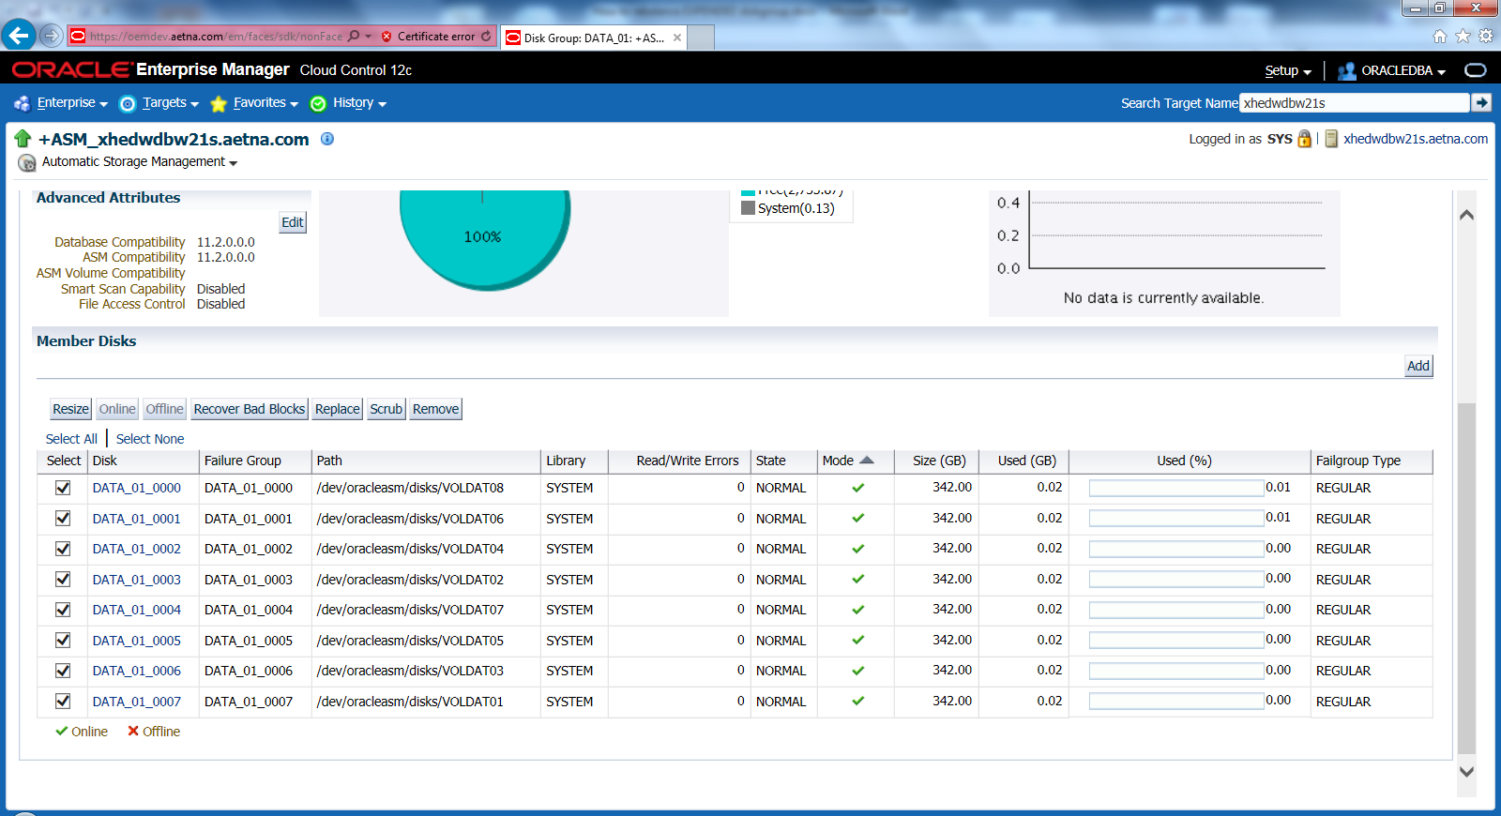

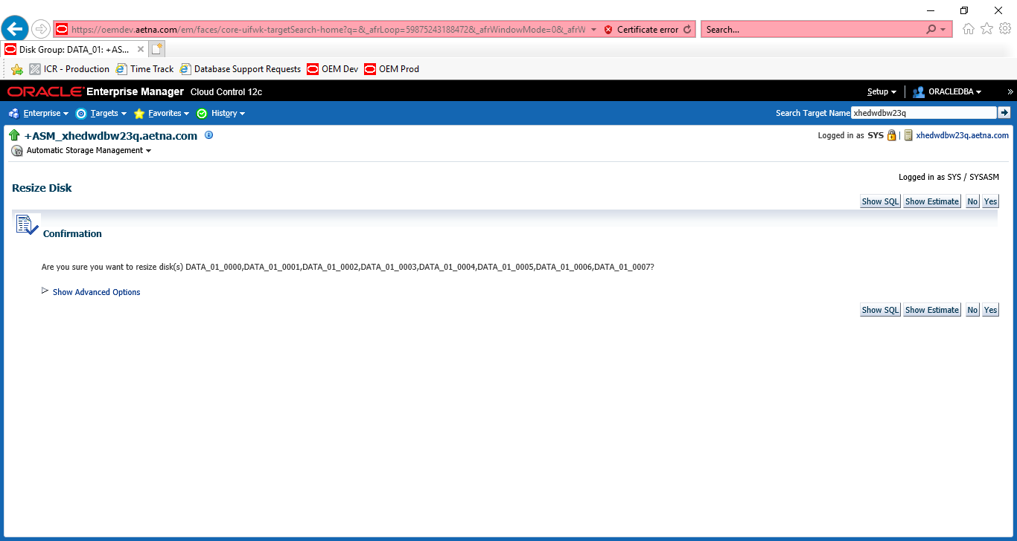

Click Show Advanced Options and use Rebalance Power 500

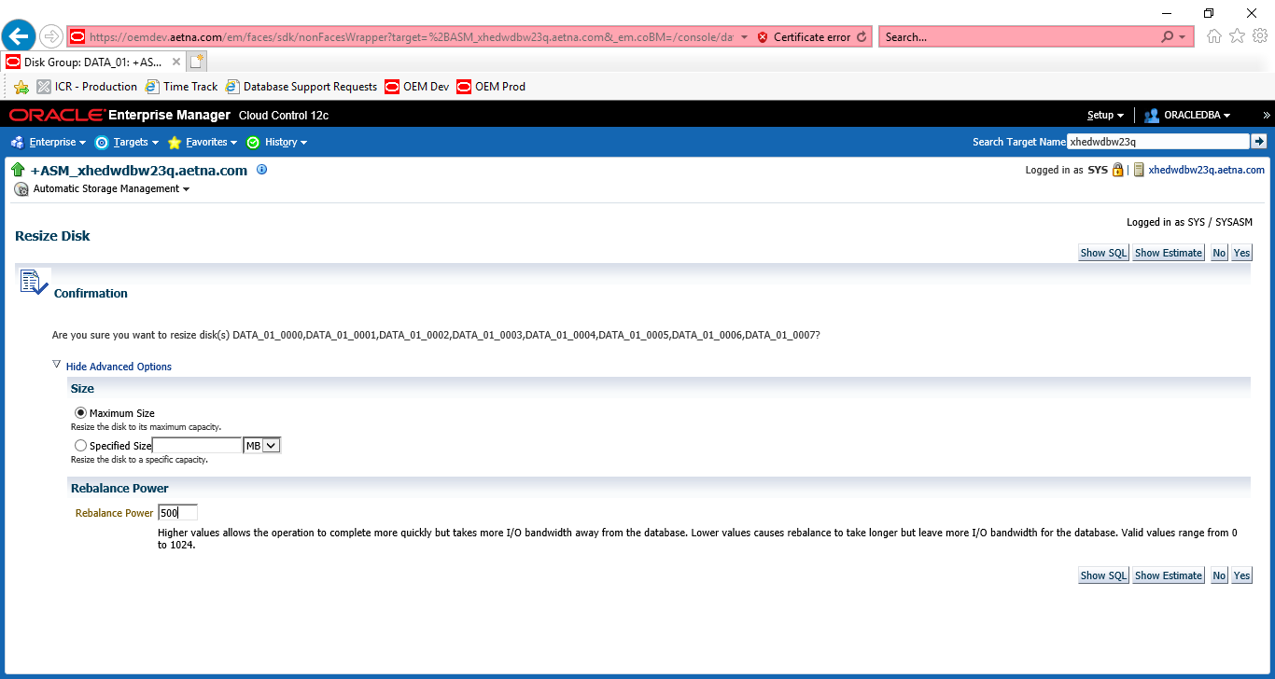

If this database not in use no need to use any power. Use defaults

Last thing just to make sure. Run following script to see space allocation.

sqlplus / as sysdba

@showasm

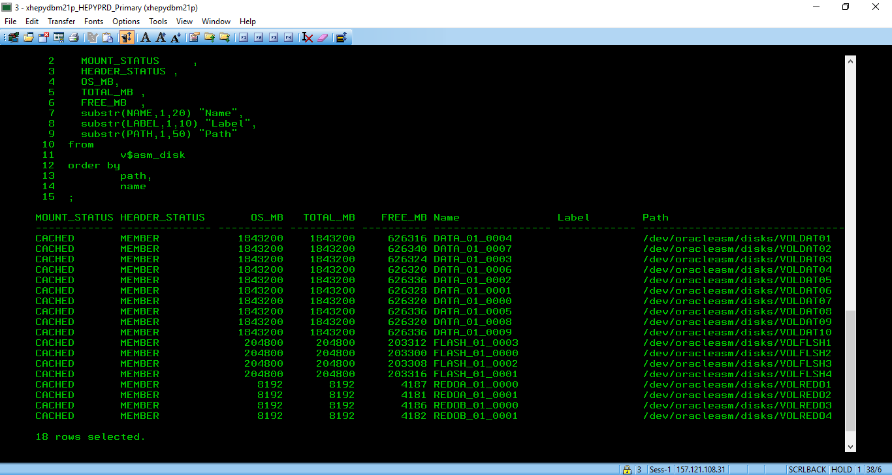

You can also run following query. Example below from DBArtisan

select

MOUNT_STATUS ,

HEADER_STATUS ,

OS_MB,

TOTAL_MB ,

FREE_MB ,

substr(NAME,1,20) "Name",

substr(LABEL,1,10) "Label",

substr(PATH,1,50) "Path"

from

v$asm_disk

order by

path,

name

;

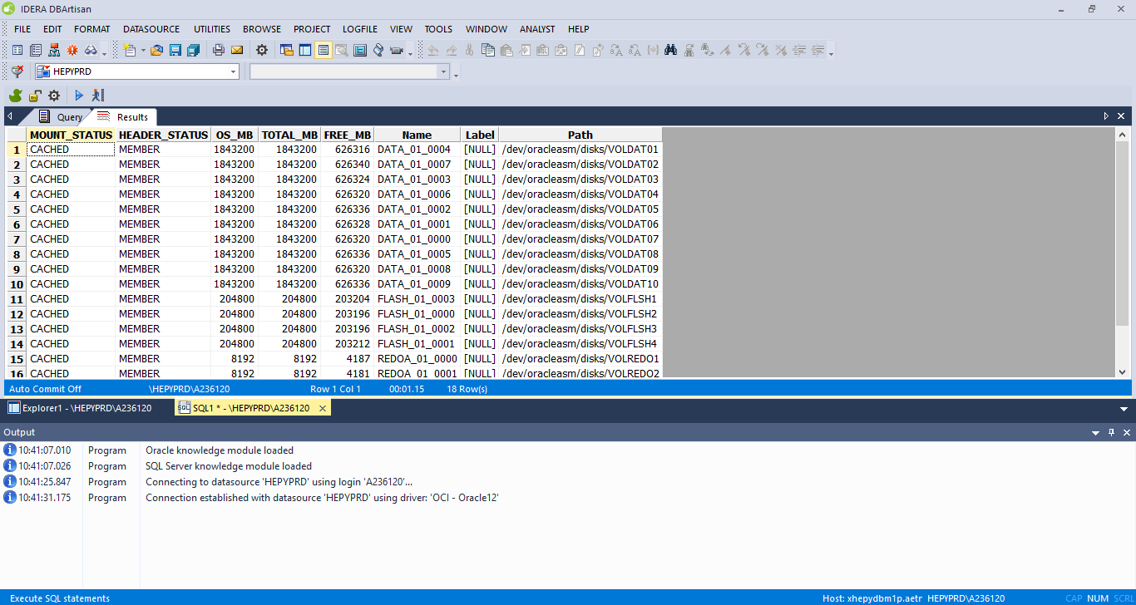

So now we can add datafiles to the tablespace or stretch existing for example from 16 GB to 24 GB or from 24 GB to 31 GB